Animal Description Template / Report Card
Option One: Each student chooses an animal to analyse
Option Two: Each group gets an A3 page of this and chooses one to do together
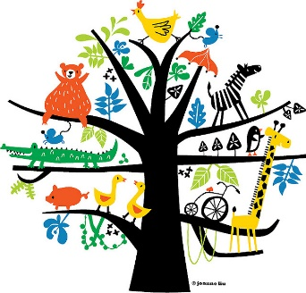

Draw a picture of your animal
Name: Date:
Name of animal: ___________________________
Observable Features:
1. _______________________________________
2. _______________________________________
3. _______________________________________
Classification group:
_________________________________________
_________________________________________

Justify why your chosen animal belongs to that particular classification group?
_______________________________________________________________
_______________________________________________________________
What other animals belong to this classification group?
_______________________________________________________________

Picture of your animal

