Animal Description Template

Name: Date:

Name of animal: ___________________________

Observable Features:

1. _______________________________________

2. _______________________________________

3. _______________________________________

Animal group:

_________________________________________

_________________________________________

Justify why your chosen animal belongs to that particular animal group?

_______________________________________________________________

_______________________________________________________________

What other animals belong to this animal group?

_______________________________________________________________

Picture of your animal

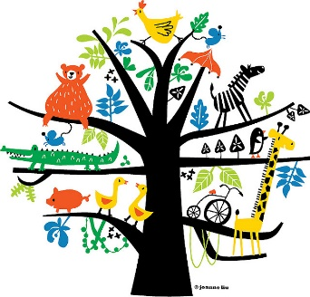

Draw a picture of your animal